**IMAGES AND DESCRIPTION**

In this, we predict 4 types of brain tumor namely 'pituitary_tumor, meningioma_tumor, glioma_tumor, and also we have a dataset of no brain tumor.

So here we use numpy , pandas , matplotlibs(graph) , sklearn , logistic regression and support vector machine.

So we use binary classification for predicting whether brain tumor or not.

We store our data set in array.

**FIG 1. VISUALISING DATA**

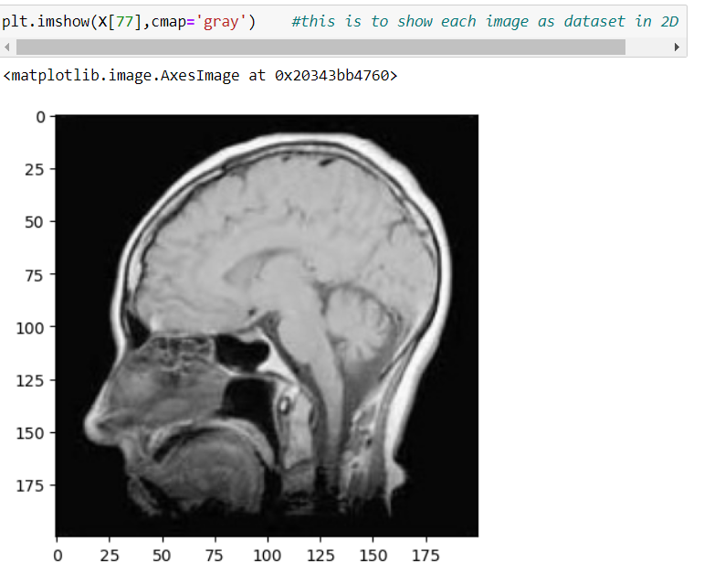

**Description:**

In this we can visualise our data set images through the command **plt. imshow(X[77],cmap='gray')** which shows the image in77th position.

**FIG 2 . VISUALISING PREDICTED RESULT**

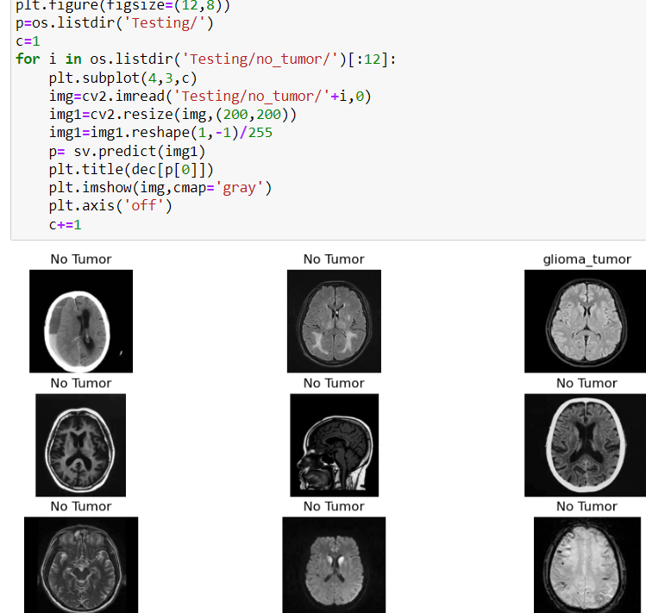

**DESCRIPTION:**

In this figure, we observe our predicted result.

For example: In this, we figure we took our **no-tumor testing dataset**

And we try to predict from our model whether it gave the correct result or not. And we observe in this fig that **8 out of 9 images gave result of no-tumor which is correct output** that shows that overall accuracy is very good. We can predict the same for other tumor images through this project.

**FIG 3: CLASSIFICATION REPORT**

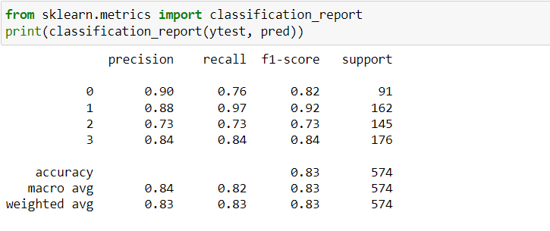

**DESCRIPTION:**

In this figure, we gave the classification report of our model.

And in this, we observe that for all four tumors, we get precision of 0.90, 0.88, 0.73, 0.84 **we get overall accuracy of 83.75 %.**

**FIG 4: ACCURACY GRAPH**

**DESCRIPTION:** In this, we get an accuracy graph in this out of 574 testing image we observe that nearly 480 images are predicted correctly .

